Initial findings empirically examining bond yields in 1990s Sweden from monthly data

Figure: debt and bond yields trends 1990 to 2000 with different maturity*

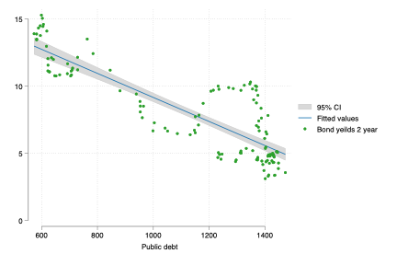 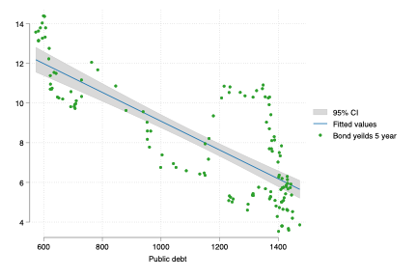¨ 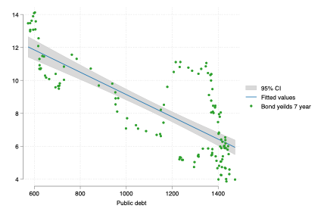 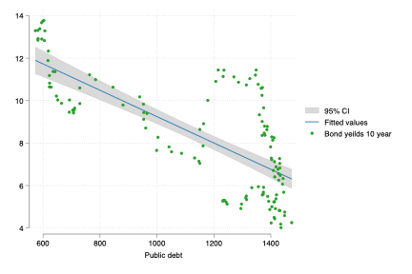
Comment: negative relation but clear that one period does not fit on the right hand side of the figure (these observations are 1994 and 1995).

*Figure debt and bond yields trends 1993 to 1996*
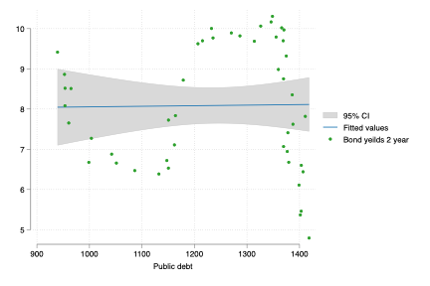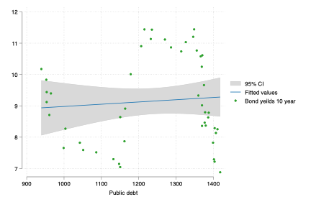
Comment: Important during the middle of the debt crisis there is no clear trend but temporary it seems to be a negative relationship

Figure: Repo rate and bond yields trends 1990 to 2000 with different maturity
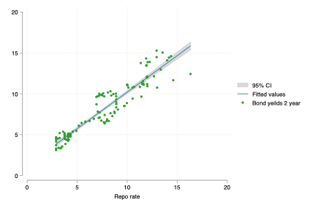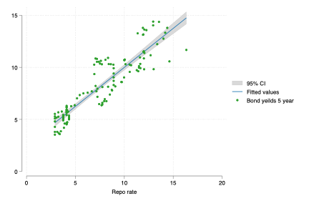
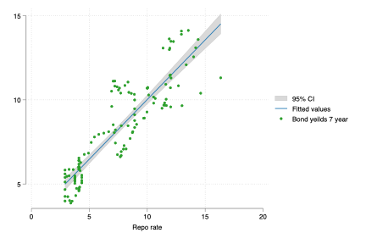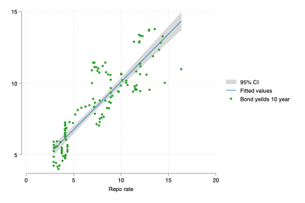

Figure: Repo rate and bond yields trends 1993 to 1996 with different maturity
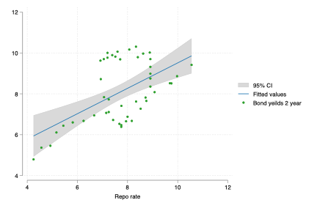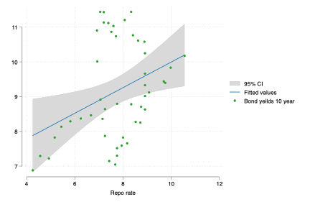

Table: OLS Bond yields, public debt and repo rate 1990 to 2000
 | 2-year bond | 5-year bond | 7-year bond | 10-year bond | 10-year bond spread
Public debt | -0.008*** | -0.006*** | -0.006*** | -0.005*** | -0.004***
 | (0.00) | (0.00) | (0.00) | (0.00) | (0.00)
Repo rate | 0.092*** | 0.075** | 0.067** | 0.064* | 0.017
 | (0.02) | (0.02) | (0.02) | (0.03) | (0.01)
Constant | 16.171*** | 14.771*** | 14.493*** | 14.099*** | 10.475***
 | (0.74) | (0.77) | (0.77) | (0.78) | (0.33)
Sources:

Table: OLS Bond yeilds, public debt and repo rate 1994 to 1996
 | 2-year bond | 5-year bond | 7-year bond | 10-year bond | 10-year bond spread
Public debt | 0.004** | 0.004** | 0.004** | 0.003* | 0.000
 | (0.00) | (0.00) | (0.00) | (0.00) | (0.00)
Repo rate | 0.827*** | 0.670*** | 0.585*** | 0.538** | 0.109
 | (0.14) | (0.16) | (0.16) | (0.16) | (0.06)
Constant | -2.738 | -1.773 | -0.300 | 1.339 | 5.536***
 | (2.27) | (2.58) | (2.52) | (2.46) | (0.97)
Sources:

Table: OLS Bond yields, public debt and repo rate 1993 to 1995
 | 2-year bond | model2 | model3 | model4 | model5
Public debt | 0.006*** | 0.006*** | 0.005*** | 0.005** | 0.001
 | (0.00) | (0.00) | (0.00) | (0.00) | (0.00)
Repo rate | 0.377 | 0.239 | 0.190 | 0.165 | -0.022
 | (0.19) | (0.24) | (0.24) | (0.24) | (0.09)
Constant | -1.154 | -0.293 | 1.091 | 2.568 | 5.975***
 | (2.37) | (2.96) | (2.97) | (2.92) | (1.16)

Comment: During the short time span of 1994 and 1995 the public debt is the only significant variable. But the coefficient for the repo rate is still much larger

Table: OLS Bond yields, public debt and repo rate 1993 to 2000
 | 2-year bond | model2 | model3 | model4 | model5
Public debt | 0.002** | 0.003** | 0.003** | 0.003** | 0.000
 | (0.00) | (0.00) | (0.00) | (0.00) | (0.00)
Repo rate | 0.933*** | 0.905*** | 0.899*** | 0.928*** | 0.357***
 | (0.06) | (0.06) | (0.07) | (0.07) | (0.03)
Constant | -2.169 | -2.715 | -2.181 | -1.860 | 3.623***
 | (1.36) | (1.60) | (1.60) | (1.62) | (0.86)

First difference part of the analysis
Debt to yield 1990 to 2000
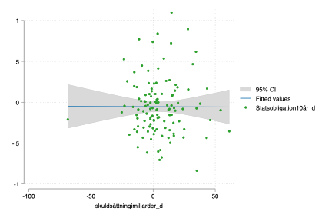
Comment: Nonsense relation

Debt to yield 1993 to 1995
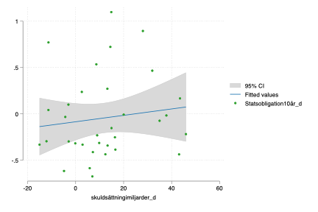
Comment: Something

Repo to yield 1990 to 2000
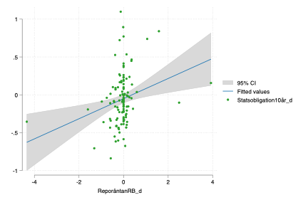

Repo to yield 1993 to 1995
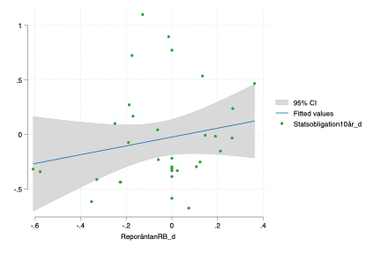

OLS part

Table: First difference OLS estimation of Bond yields, public debt and repo rate 1990 to 2000
 | 2-year bond | 5-year bond | 7-year bond | 10-year bond | 10-year spread
Public debt | -0.001 | -0.001 | -0.000 | -0.000 | -0.002
 | (0.00) | (0.00) | (0.00) | (0.00) | (0.00)
Repo rate | 0.021*** | 0.011** | 0.009* | 0.007* | -0.001
 | (0.00) | (0.00) | (0.00) | (0.00) | (0.00)
Constant | -0.050 | -0.049 | -0.053 | -0.053 | -0.012
 | (0.04) | (0.04) | (0.03) | (0.03) | (0.02)
N | 121 | 121 | 121 | 121 | 121
Sources:

Table: First difference OLS Bond yields, public debt and repo rate 1993 to 1996
 | 2-year bond | 5-year bond | 7-year bond | 10-year bond | 10-year bond spread
Public debt | 0.003 | 0.002 | 0.001 | 0.001 | -0.003
 | (0.00) | (0.00) | (0.00) | (0.00) | (0.00)
Repo rate | 0.512* | 0.389 | 0.350 | 0.274 | -0.024
 | (0.21) | (0.25) | (0.26) | (0.26) | (0.11)
Constant | -0.053 | -0.043 | -0.036 | -0.034 | -0.005
 | (0.07) | (0.08) | (0.08) | (0.09) | (0.04)
Sources:

Table: First difference OLS Bond yields, public debt and repo rate 1993 to 2000
 | 2-year bond | 5-year bond | 7-year bond | 10-year bond |  | 10-year spread
Public debt | 0.001 | 0.001 | 0.001 |  | 0.001 |  | -0.001
 | (0.00) | (0.00) | (0.00) |  | (0.00) |  | (0.00)
Repo rate | 0.580*** | 0.409* | 0.328 |  | 0.236 |  | -0.051
 | (0.14) | (0.17) | (0.17) |  | (0.17) |  | (0.09)
Constant | -0.018 | -0.020 | -0.030 |  | -0.036 |  | -0.024
 | (0.03) | (0.04) | (0.04) |  | (0.04) |  | (0.02)
N | 88 | 88 | 88 |  | 88 |  | 88

VAR part

Figure: VAR IRF Bond yields, public debt and repo rate
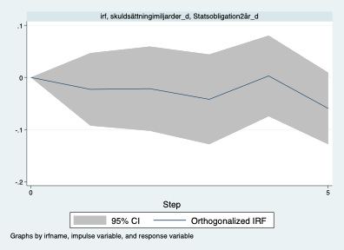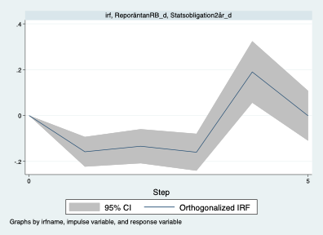

Figure: VAR IRF Bond yields, public debt and repo rate 1993 to 2000
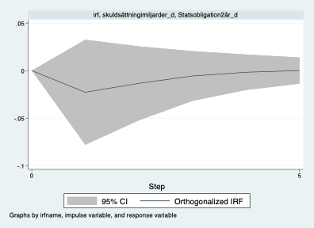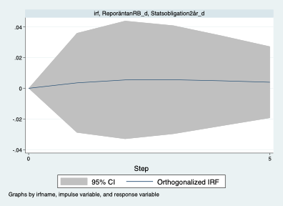

Granger causality Wald tests

Equation | Excluded | chi2 | df | Prob > chi2
Statsobliga~2år_d | skuldsättningim~d | .38962 | 3 | 0.942
Statsobliga~2år_d | ReporäntanRB_d | 40.793 | 3 | 0.000
Statsobliga~2år_d | ALL | 48.229 | 6 | 0.000
skuldsättningim~d | Statsobliga~2år_d | .26345 | 3 | 0.967
skuldsättningim~d | ReporäntanRB_d | 6.5201 | 3 | 0.089
skuldsättningim~d | ALL | 8.9941 | 6 | 0.174
ReporäntanRB_d | Statsobliga~2år_d | 19.285 | 3 | 0.000
ReporäntanRB_d | skuldsättningim~d | 2.1606 | 3 | 0.540
ReporäntanRB_d | ALL | 20.862 | 6 | 0.002

